Chapter 2
Mathematical modelling of bacterial resistance to multiple antibiotics and immune system response
2.1 Overview
2.1.1 Bacterial Infections and Antibiotic Resistance
Bacterial infections remain a leading cause of disease and death globally, affecting millions of people each year across all age groups and healthcare settings. The introduction of penicillin in the 1940s marked the beginning of the antibiotic era, offering effective treatment for infections that had previously carried high mortality. Since then, numerous classes of antibiotics have been developed, each targeting different aspects of bacterial physiology such as cell wall synthesis, protein production, or DNA replication.
However, bacteria are capable of rapid evolutionary adaptation. Resistance to antimicrobial agents is now recognized as both a logical and inevitable consequence of antibiotic use. Each new class of antibiotic introduced into clinical practice has been followed within years, and sometimes months, by the emergence of resistant strains. Resistance mechanisms include enzymatic inactivation of the drug, modification of the drug target, active efflux of the drug from the bacterial cell, and reduced membrane permeability. These mechanisms can arise through spontaneous chromosomal mutations or through the acquisition of resistance genes from other bacteria via horizontal gene transfer.
2.1.2 Multiple Antibiotic Therapy
The use of two or more antibiotics simultaneously, known as combination or multiple antibiotic therapy, has become standard practice for several types of bacterial infection. The rationale for this approach is threefold. First, different antibiotics act on different bacterial targets, so their effects can be additive or synergistic, producing greater bacterial killing than either drug alone. Second, combination therapy reduces the probability of resistance emerging, since a single mutation is unlikely to confer resistance to two drugs with different mechanisms simultaneously. Third, for mixed infections involving multiple bacterial species or strains with different susceptibility profiles, combinations ensure that all components of the infection are covered.
2.1.3 Mathematical Modelling in Infectious Diseases
Mathematical modelling has a long history in the study of infectious diseases. The foundational SIR model, which divides a population into susceptible, infected, and recovered compartments, was introduced in the early twentieth century and remains widely used today for studying epidemic dynamics. More sophisticated extensions of this framework have been developed to account for latent infection, vaccination, age structure, spatial heterogeneity, and many other biological complexities.
2.1.4 Within-Host Models vs Epidemiological Models
Mathematical models of infectious disease can be broadly divided into two categories based on their scale of analysis. Epidemiological models, also called between-host models, describe the spread of infection across a population of individuals. These models are used to predict outbreak trajectories, evaluate vaccination programs, and assess the impact of public health interventions. The SIR model and its variants fall into this category.
Within-host models, by contrast, describe the dynamics of infection inside a single individual. These models track the populations of pathogens, immune cells, and drugs over time within one host and are used to understand the mechanisms of infection progression, immune evasion, and treatment response. Within-host models are particularly relevant for studying antibiotic resistance because resistance develops at the level of individual bacterial cells within a patient, driven by mutation and selection pressure from drugs and immunity.
2.2 Mathematical Model
2.2.1 Model Description and Assumptions
This study examines the within-host dynamics of a bacterial infection in a single patient receiving multiple antibiotic treatment. Unlike epidemiological models such as SIR which track disease spread across a population, this model focuses on what happens inside one individual's body. Specifically, how sensitive bacteria, resistant bacteria, immune cells, and antibiotic concentrations interact and change over time.
The model is built as a system of ordinary differential equations (ODEs) with five state variables: the concentration of antibiotic-sensitive bacteria s(t), antibiotic-resistant bacteria r(t), host immune cells b(t), and the concentrations of two antibiotics — isoniazid INH denoted a1(t) and pyrazinamide PZA denoted a2(t). All five variables are normalized, meaning their values fall between 0 and 1, where 1 represents the maximum possible concentration or population size.
2.2.2 State Variables and Parameters
State Variables
The model consists of five state variables, all of which are normalized to dimensionless values in the range [0, 1]. Normalization is achieved by dividing each variable by its respective maximum capacity, which simplifies the mathematical analysis and ensures all variables remain biologically meaningful.
Variable | Meaning | Normalization | Range
s(t) | Population of antibiotic-sensitive bacteria at time t | S(t) divided by carrying capacity T | [0, 1]
r(t) | Population of antibiotic-resistant bacteria at time t | R(t) divided by carrying capacity T | [0, 1]
b(t) | Population of host immune cells at time t | B(t) divided by ωT | [0, 1]
a1(t) | Concentration of INH (Isoniazid) at time t | A1(t) divided by δ1/μ1 | [0, 1]
a2(t) | Concentration of PZA (Pyrazinamide) at time t | A2(t) divided by δ2/μ2 | [0, 1]
Where T is the carrying capacity of bacteria, ω is the ratio of immune cell capacity to bacterial capacity, δi is the supply rate of the i-th antibiotic, and μi is the clearance rate of the i-th antibiotic.
Parameters
The model contains the following parameters. Each parameter is strictly positive as required for biological validity.
Parameter | Symbol | Meaning | Unit
Sensitive bacteria growth rate | βS | Maximum per capita growth rate of sensitive bacteria | day⁻¹
Resistant bacteria growth rate | βR | Maximum per capita growth rate of resistant bacteria | day⁻¹
Fitness cost of resistance | c | Fractional reduction in growth rate due to carrying resistance genes | dimensionless
Immune killing rate | η | Rate at which immune cells kill bacteria per unit concentration | day⁻¹
Immune cell growth rate | k | Per capita proliferation rate of immune cells in response to infection | day⁻¹
Mutation rate — INH | α1 | Rate at which sensitive bacteria mutate to resistant due to INH exposure | day⁻¹
Mutation rate — PZA | α2 | Rate at which sensitive bacteria mutate to resistant due to PZA exposure | day⁻¹
Antibiotic killing rate — INH | d1 | Rate at which INH kills sensitive bacteria | day⁻¹
Antibiotic killing rate — PZA | d2 | Rate at which PZA kills sensitive bacteria | day⁻¹
INH clearance rate | μ1 | Rate at which INH is cleared from the body | day⁻¹
PZA clearance rate | μ2 | Rate at which PZA is cleared from the body | day⁻¹
2.2.3 The ODE System
The model is governed by a system of five ordinary differential equations describing the time evolution of sensitive bacteria, resistant bacteria, immune cells, and two antibiotic concentrations.
Equation 1 — Sensitive Bacteria
$\frac{ds}{dt}$= βS · s · (1−s−r) − η · s · b − s · [(α1+d1) · a1 + (α2+d2) · a2]
Term | Expression | Meaning
Logistic growth | βS · s · (1−s−r) | Sensitive bacteria grow at rate βS but slow down as total bacteria s+r approach carrying capacity
Immune killing | η · s · b | Immune cells destroy sensitive bacteria at rate η proportional to both populations
Antibiotic effect | s · Σ(αi+di) · ai | Antibiotics kill sensitive bacteria at rate di and convert them to resistant through mutation at rate αi

Equation 2 — Resistant Bacteria
$\frac{dr}{dt}$ = βR · r · (1−s−r) − η · r · b + s · [α1 · a1 + α2 · a2]
Term | Expression | Meaning
Logistic growth | βR · r · (1−s−r) | Resistant bacteria grow at rate βR which is lower than βS due to fitness cost c
Immune killing | η · r · b | Immune cells kill resistant bacteria at the same rate η as sensitive bacteria
Mutation gain | s · Σαi · ai | Sensitive bacteria mutate into resistant ones upon antibiotic exposure — this is a gain for r and a loss for s
Equation 3 — Immune Cells
$\frac{db}{dt}$ = k · b · (1 − b/(s+r))
Term | Expression | Meaning
Logistic growth | k · b · (1 − b/(s+r)) | Immune cells proliferate at rate k with carrying capacity equal to total bacterial load s+r. When bacteria decrease the immune response also contracts. When s+r = 0 immune cells decay at rate k

Equation 4 and 5 — Antibiotic Concentrations
$\frac{da1}{dt}$ = μ1 · (1 − a1)
$\frac{da2}{dt}$ = μ2 · (1 − a2)
Term | Expression | Meaning
INH dynamics | μ1 · (1 − a1) | INH is supplied continuously and cleared at rate μ1 driving concentration toward normalized steady state of 1
PZA dynamics | μ2 · (1 − a2) | Same structure as INH with its own clearance rate μ2
Complete System
$\frac{ds}{dt}$= βS · s · (1−s−r) − η · s · b − s · [(α1+d1) · a1 + (α2+d2) · a2]
$\frac{dr}{dt}$ = βR · r · (1−s−r) − η · r · b + s · [α1 · a1 + α2 · a2]
$\frac{db}{dt}$ = k · b · (1 − b/(s+r))
$\frac{da1}{dt}$ = μ1 · (1 − a1)
$\frac{da2}{dt}$ = μ2 · (1 − a2)
Biological Constraints
The following constraints must hold at all times for the system to remain biologically valid:
Constraint | Meaning
s(t) ≥ 0 | Sensitive bacteria cannot be negative
r(t) ≥ 0 | Resistant bacteria cannot be negative
0 ≤ b(t) ≤ s+r | Immune cells are bounded by bacterial load
0 ≤ ai(t) ≤ 1 | Antibiotic concentrations are normalized
s(t) + r(t) ≤ 1 | Total bacteria cannot exceed carrying capacity

2.2.4 Normalization of Variables
The original system before normalization is:
$\frac{dS}{dt}$ = βS · S · (1 − (S+R)/T) − λ · S · B − S · Σ ᾱi · Ai − S · Σ d̄i · Ai
$\frac{dR}{dt}$ = βR · R · (1 − (S+R)/T) − λ · R · B + S · Σ ᾱi · Ai
$\frac{dB}{dt}$= k · B · (1 − B/(ω(S+R)))
$\frac{dAi}{dt}$= δi − μi · Ai for i = 1, 2
Substitution Step
We introduce the following normalized variables:
s(t) = $\frac{S(t)}{T}$ , r(t) = $\frac{R(t)}{T}$ , b(t) =$\frac{B(t)}{ωT}$ , ai(t) = $\frac{ Ai(t) }{ δi/μi }$
With the new variables, the normalized system is given as:
$\frac{ds}{dt}$= βS · s · (1−s−r) − η · s · b − s · [(α1+d1) · a1 + (α2+d2) · a2]
$\frac{dr}{dt}$ = βR · r · (1−s−r) − η · r · b + s · [α1 · a1 + α2 · a2]
$\frac{db}{dt}$ = k · b · (1 − b/(s+r))
$\frac{da1}{dt}$ = μ1 · (1 − a1)
$\frac{da2}{dt}$ = μ2 · (1 − a2)
The normalization step reduces the number of independent parameters by combining them:
New Parameter | Formula | Meaning
η | λ · ω · T | Combined immune killing rate in normalized system
αi | ᾱi · (δi/μi) | Normalized mutation rate for i-th antibiotic
di | d̄i · (δi/μi) | Normalized killing rate for i-th antibiotic
βR | (1−c) · βS | Resistant growth rate incorporating fitness cost

2.2.5 Threshold Parameters A, B and C
Three threshold parameters are derived from the model parameters. These parameters determine which equilibrium the system converges to and therefore determine the long-term outcome of the infection.
Parameter | Formula | Meaning
A | (βS − Σ(αi + di)) / (βS + η) | Net Survival Ability of Sensitive Bacteria
B | βR / (βR + η) | Net Survival Ability of Resistant Bacteria
C | Σαi / (βR + η) | Mutation Contribution

Written explicitly for two antibiotics:
A = $\frac{βS - \left(α1+d1\right) - (α2+d2) }{βS + η}$
B = $\frac{βR}{βR + η}$
C = $\frac{α1 + α2}{ βR + η}$
The Key Threshold Condition
The entire long-term behavior of the system depends on comparing A and B:
Condition | Outcome
A < B | Sensitive bacteria die out. Only resistant bacteria and immune cells persist at equilibrium E2. Antibiotics have failed to prevent resistance dominance.
A > B | Both sensitive and resistant bacteria coexist with immune cells at equilibrium E3. Neither type is eliminated.
A < B → E2 is stable → resistant bacteria dominate
A > B → E3 is stable → coexistence of both types
2.3 Mathematical Analysis
2.3.1 Equilibrium Points
Equilibrium points are found by setting all derivatives equal to zero and solving the resulting algebraic system.
$\frac{ds}{dt}$ = 0
$\frac{dr}{dt}$ = 0
$\frac{db}{dt}$ = 0
$\frac{dai}{dt}$ = 0 for i = 1, 2
From $\frac{dai}{dt}$ = 0
- μi · (1 − ai) = 0
- ai = 1 for i = 1, 2
All equilibrium points have a1 = a2 = 1. Substituting ai = 1 into the remaining three equations reduces the system to:
βS·s·(1−s−r) − η·s·b − s·Σ(αi+di) = 0 ... (i)
βR·r·(1−s−r) − η·r·b + s·Σαi = 0 ... (ii)
k·b·(1 − b/(s+r)) = 0 ... (iii)
From equation (iii) either:
b = 0 (no immune response) or b = s + r (immune cells at maximum capacity)
Case 1 — When b = 0
Substituting b = 0 into (i) and (ii):
s · [βS·(1−s−r) − Σ(αi+di)] = 0
r · [βR·(1−s−r)] = 0
This gives s = 0 and r = 0
Subcase s = 0, r = 0 → gives E0
Subcase s = 0, r ≠ 0 → from βR·(1−r) = 0 → r = 1 → gives E1
Subcase s ≠ 0, r ≠ 0 → gives a point where s and r have opposite signs which is biologically meaningless. so, its rejected.
Case 2 — When b = s + r
Substituting b = s+r into (i) and (ii):
s · [βS·(1−s−r) − η·(s+r) − Σ(αi+di)] = 0 ... (iv)
r · [βR·(1−s−r) − η·(s+r)] + s·Σαi = 0 ... (v)
Subcase s = 0 → substituting into (v):
r · [βR·(1−r) − η·r] = 0
r · [βR − (βR+η)·r] = 0
r = βR/(βR+η) = B → gives E2
Subcase s ≠ 0 → from (iv) the bracket equals zero:
βS·(1−s−r) − η·(s+r) − Σ(αi+di) = 0
(βS+η)·(1−s−r) = βS − Σ(αi+di)
(s+r) = [βS − Σ(αi+di)]/(βS+η) = A = b̄
Substituting back gives s̄ and r̄ → gives E3
Equilibrium | Values | Exists When | Biological Meaning
E0 | (0, 0, 0, 1, 1) | Always | System can always be infection free in theory
E1 | (0, 1, 0, 1, 1) | Always | Full resistant bacteria dominance always possible
E2 | (0, B, B, 1, 1) | Always | Resistant bacteria and immune coexistence always possible
E3 | (s̄, r̄, b̄, 1, 1) | A > B only | Coexistence only when sensitive bacteria are relatively strong

2.3.2 Stability Analysis
The Jacobian Matrix
Stability is determined by linearizing the system around each equilibrium point. This gives the Jacobian matrix J evaluated at each equilibrium:
J = $\left[\begin{matrix}\frac{∂φ1}{∂s} & \frac{∂φ1}{∂r} & \frac{∂φ1}{∂b} & \frac{∂φ1}{∂a1} & \frac{∂φ1}{∂a2} \\ \frac{∂φ2}{∂s} & \frac{∂φ2}{∂r} & \frac{∂φ2}{∂b} & \frac{∂φ2}{∂a1} & \frac{∂φ2}{∂a2} \\ \frac{∂φ3}{∂s} & \frac{∂φ3}{∂r} & \frac{∂φ3}{∂b} & \frac{∂φ3}{∂a1} & \frac{∂φ3}{∂a2} \\ \frac{∂φ4}{∂s} & \frac{∂φ4}{∂r} & \frac{∂φ4}{∂b} & \frac{∂φ4}{∂a1} & \frac{∂φ4}{∂a2} \\ \frac{∂φ5}{∂s} & \frac{∂φ5}{∂r} & \frac{∂φ5}{∂b} & \frac{∂φ5}{∂a1} & \frac{∂φ5}{∂a2}\end{matrix}\right]$
Where φ1...φ5 are the right-hand sides of the five ODEs. Evaluated explicitly:
J = $\left[\begin{matrix}βS-2βSs-βSr-ηb-Σ(αi+di)ai & -βSs & -ηs & -s(α1+d1) & -s(α2+d2) \\ -βRr+Σαiai & βR-βRs-2βRr-ηb & -ηr & sα1 & sα2 \\ kb²/(s+r)² & kb²/(s+r)² k-2kb/(s+r) & k-2kb/(s+r) & 0 & 0 \\ 0 & 0 & -μ1 & -μ1 & 0 \\ 0 & 0 & 0 & 0 & -μ2\end{matrix}\right]$
The eigenvalues λ of J at each equilibrium determine stability:
All eigenvalues have negative real parts → equilibrium is Stable
Any eigenvalue has positive real part → equilibrium is unstable
Routh-Hurwitz Criteria
For a 5×5 Jacobian, finding eigenvalues directly requires solving a degree-5 polynomial — which has no general closed form solution. The Routh-Hurwitz criteria allow us to determine whether all roots have negative real parts without solving for the roots explicitly.
The Criteria
Given characteristic polynomial:
P(λ) = λⁿ + a1λⁿ⁻¹ + a2λⁿ⁻² + ... + an = 0
All roots have negative real parts if and only if all Hurwitz determinants are positive.
For n = 2:
Conditions: a1 > 0 and a2 > 0
For n = 3:
Conditions: a1 > 0 and a3 > 0 and a1·a2 > a3
Stability of E0
λ1 = βS − Σ(αi+di) (can be positive)
λ2 = βR > 0 (always positive)
Since λ2 = βR is always positive by definition of parameters, E0 is always unstable. The infection free state cannot be maintained.
Stability of E1
λ1 = −Σ(αi+di) < 0
λ2 = −βR < 0
λ3 = k > 0 (always positive)
Since λ3 = k is always positive, E1 is always unstable. Pure resistant bacteria without any immune response cannot be maintained.
Stability of E2
Substituting E2 = (0, B, B, 1, 1) into J
The eigenvalues from the last two rows are immediately:
λ4 = −μ1 < 0
λ5 = −μ2 < 0
These are always stable. The remaining three eigenvalues come from the block matrix:
JB(E2) = $\left[\begin{matrix}βS(1-B) - η·B - Σ(αi+di) & 0 & 0 \\ -βR·B + Σαi & -βR·B - η·B & 0 \\ k & k & -k\end{matrix}\right]$
The characteristic equation factors as:
[βS(1−B) − ηB − Σ(αi+di) − λ] · [λ² + λ(k + βR·B) + k·βR·B] = 0
This gives:
λ2,1 = βS(1−B) − ηB − Σ(αi+di)
= (βS + η) · (A − B)
And λ2,2 and λ2,3 from:
λ² + (k + βR·B). λ + k·βR·B = 0
Applying Routh-Hurwitz with n=2:
a1 = k + βR·B > 0 (all parameters positive)
a2 = k·βR·B > 0 (all parameters positive)
So λ2,2 and λ2,3 always have negative real parts.
The only condition remaining is the sign of λ2,1:
λ2,1 = (βS + η)(A − B)
A < B → A − B < 0 → λ2,1 < 0 → E2 is stable
A > B → A − B > 0 → λ2,1 > 0 → E2 is unstable
Therefore, E2 is stable if and only if A < B
Stability of E3
Substituting E3 = (s̄, r̄, b̄, 1, 1) into J
Again the last two eigenvalues are:
λ4 = −μ1 < 0
λ5 = −μ2 < 0
The remaining three eigenvalues come from the block matrix:
JB(E3) = $\left[\begin{matrix}-βS·s̄ & -βS·s̄ & -η·s̄ \\ -βR·r̄ + Σαi & βR(1-b̄) - η·b̄ - βR·r̄ & -η·r̄ \\ k & k & -k\end{matrix}\right]$
The characteristic equation is:
λ³ + a1·λ² + a2·λ + a3 = 0
Where:
a1 = s̄·r̄·Σαi + βR·r̄ + βS·s̄ + k
a2 = k(s̄·r̄·Σαi + βR·r̄ + βS·s̄) + b̄·η·k + βS·b̄·s̄·r̄·Σαi
a3 = k·η·b̄·s̄·r̄·Σαi + k·βS·b̄·s̄·r̄·Σαi
Applying Routh-Hurwitz with n=3:
a1 > 0 (all terms positive since s̄, r̄, b̄ > 0 when A > B)
a3 > 0 (all terms positive)
a1·a2 > a3
All three Routh-Hurwitz conditions are satisfied whenever E3 exists, that is whenever A > B.
Therefore, E3 is stable if and only if A > B.
Summary Table
Equilibrium | Eigenvalue Signs | Stability Condition
E0 | At least one positive | Always unstable
E1 | At least one positive | Always unstable
E2 | All negative when A < B | A < B
E3 | All negative when A > B | A > B

Biological Interpretation of Each Equilibrium
Equilibrium | Biological Meaning
E0 | Infection free state. Theoretically possible but always unstable — any small bacterial introduction will grow and push the system away from this point.
E1 | Resistant bacteria completely dominate with no immune response. Always unstable — any immune activation will disturb this state.
E2 | Sensitive bacteria are eliminated by antibiotics. Only resistant bacteria remain, held in balance by the immune system. This is the worst clinical outcome — resistance has won.
E3 | Both sensitive and resistant bacteria coexist with active immune response. Neither type is fully eliminated. Antibiotics alone are insufficient to clear the infection.
2.4 Results and Discussion
2.4.1 Parameter Values Used
All parameter values used in the numerical simulations are listed below.

Biological Parameters
Symbol | Description | Value | Unit
βS | Growth rate of sensitive bacteria | 0.8 | day⁻¹
βR | Growth rate of resistant bacteria | 0.4 | day⁻¹
c | Fitness cost of resistance | 0.5 | dimensionless
η | Immune killing rate | 0.3 | day⁻¹
k | Immune cell proliferation rate | 0.6 | day⁻¹
ω | Ratio of immune cell capacity to bacterial capacity | 1 | dimensionless
T | Carrying capacity of bacteria | 10⁹ | cells

Antibiotic Parameters — Case I (A < B)
Symbol | Description | Value | Unit
α1 | Mutation rate due to INH | 0.02 | day⁻¹
d1 | Killing rate of sensitive bacteria by INH | 0.15 | day⁻¹
μ1 | Clearance rate of INH | 0.06 | day⁻¹
α2 | Mutation rate due to PZA | 0.06 | day⁻¹
d2 | Killing rate of sensitive bacteria by PZA | 0.35 | day⁻¹
μ2 | Clearance rate of PZA | 0.03 | day⁻¹

Antibiotic Parameters — Case II (A > B)
Symbol | Description | Value | Unit
βR | Growth rate of resistant bacteria | 0.1 | day⁻¹
η | Immune killing rate | 0.05 | day⁻¹
α1 | Mutation rate due to INH | 0.06 | day⁻¹
d1 | Killing rate of sensitive bacteria by INH | 0.30 | day⁻¹
α2 | Mutation rate due to PZA | 0.02 | day⁻¹
d2 | Killing rate of sensitive bacteria by PZA | 0.05 | day⁻¹
μ1 | Clearance rate of INH | 0.06 | day⁻¹
μ2 | Clearance rate of PZA | 0.03 | day⁻¹

Initial Conditions
Variable | Description | Value | Justification
s(0) | Initial sensitive bacteria | 0.80 | Heavy bacterial load at start of treatment
r(0) | Initial resistant bacteria | 0.05 | Small resistant population already present
b(0) | Initial immune cells | 0.05 | Weak immune response at start
a1(0) | Initial INH concentration | 0.05 | Antibiotic just administered
a2(0) | Initial PZA concentration | 0.02 | Antibiotic just administered

2.4.2 Threshold Values A, B and C
Computed Values for Both Cases
Parameter | Formula | Case I | Case II
A | (βS − Σ(αi+di)) / (βS+η) | 0.2000 | 0.3364
B | βR / (βR+η) | 0.5714 | 0.2500
C | Σαi / (βR+η) | 0.1143 | 0.0267
Condition | — | A < B | A > B
Stable Equilibrium | — | E2 | E3

In Case I where A < B, the antibiotics and immune system together are strong enough to eliminate sensitive bacteria completely. However resistant bacteria survive because they are unaffected by antibiotics and can only be controlled by the immune system. The system converges to E2 where only resistant bacteria and immune cells coexist at equilibrium. This represents the clinically unfavorable outcome where antibiotic resistance has effectively won.
In Case II where A > B, the antibiotics are too weak relative to the growth advantage of sensitive bacteria, or the resistant bacteria have a very high fitness cost making them slow to grow. Neither bacterial type is fully eliminated and the system converges to E3 where sensitive bacteria, resistant bacteria, and immune cells all coexist at a stable positive equilibrium.
2.4.3 Case I Results — A < B
All simulations in this section use the Case I parameters where A = 0.2000 and B = 0.5714, giving the condition A < B. The system is therefore expected to converge to equilibrium E2 = (0, 0.5714, 0.5714, 1, 1).
The following plot shows the time evolution of all five state variables under Case I parameters where A = 0.2000 < B = 0.5714.
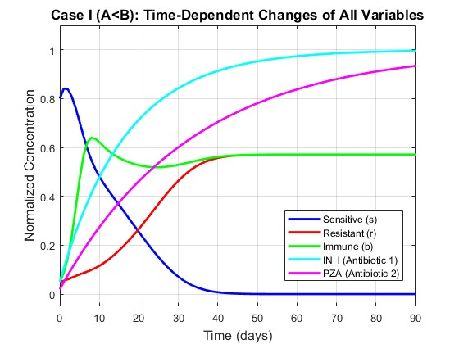Fig: 2.1 All 5 Variables Over Time (A<B)
The plot shows Sensitive bacteria steadily decline and reach zero by around day 60, wiped out by antibiotics and the immune system. Resistant bacteria survive and stabilize at a low level. Immune cells rise and settle at the same level as resistant bacteria. Both antibiotics quickly reach their maximum concentration and stay there. Overall, the system settles at equilibrium E₂ exactly as the math predicted. The immune cell spike visible in the first 5 days reflects rapid proliferation in response to the high initial bacterial load.

The following plot isolates the relationship between total bacterial load and immune cell population over time.
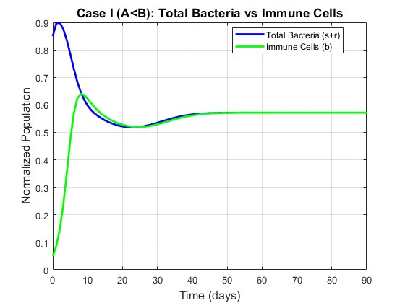
Fig: 2.2 Total Bacteria vs Immune Cells
Fig: 2.2 — Total Bacteria vs Immune Cells Shows that the immune system tracks and matches the bacterial load over time. By day 90 both curves meet at the same value, confirming that the immune system brings the infection under control — not eliminated, but held in a stable balance.

The following plot shows the pharmacokinetic behavior of both antibiotics over the 200-day treatment period.
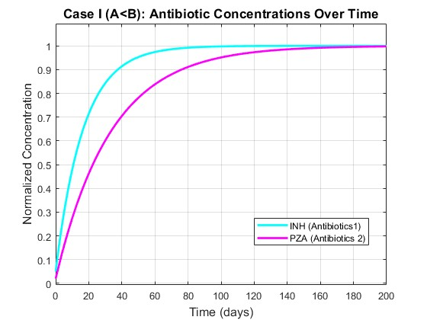

Fig: 2.3 Antibiotic Concentrations

Fig: 2.3 — Antibiotic Concentrations shows Both drugs rise quickly and plateau within the first 30 days. INH stabilizes faster than PZA due to its higher clearance rate. After that, concentrations stay constant for the rest of the treatment.

The following phase Plot shows the trajectory of sensitive bacteria s against resistant bacteria r over the 90-day period under Case I conditions.

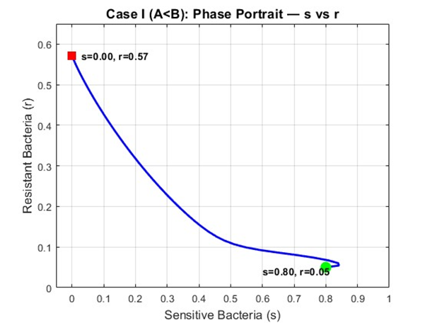

Fig: 2.4 Phase Portrait (s vs r)

The trajectory moves from the initial condition at s=0.80, r=0.05 toward the E2 equilibrium at s=0, r=0.5714. By day 90 sensitive bacteria have reached zero and resistant bacteria have stabilized at 0.5714, confirming complete convergence to E2. Comparing this with the Case II phase portrait shows the difference — in Case I the trajectory terminates on the r-axis where s=0, while in Case II the trajectory terminates at a positive s value confirming coexistence.

Numerical Results — Case I (A < B)
The following table records exact numerical values at 10-day intervals confirming convergence to E2 = (0, 0.5714, 0.5714, 1, 1).

Time (days) | Sensitive (s) | Resistant (r) | Total (s+r) | Immune Cells (b) | INH (a1) | PZA (a2)
0 | 0.8000 | 0.0500 | 0.8500 | 0.0500 | 0.0500 | 0.0200
10 | 0.4812 | 0.1157 | 0.5969 | 0.6219 | 0.4786 | 0.2740
20 | 0.2542 | 0.2671 | 0.5213 | 0.5275 | 0.7139 | 0.4622
30 | 0.0708 | 0.4641 | 0.5349 | 0.5294 | 0.8430 | 0.6016
40 | 0.0075 | 0.5577 | 0.5651 | 0.5617 | 0.9138 | 0.7048
50 | 0.0004 | 0.5706 | 0.5710 | 0.5707 | 0.9527 | 0.7813
60 | 0.0000 | 0.5714 | 0.5714 | 0.5714 | 0.9740 | 0.8380
70 | 0.0000 | 0.5714 | 0.5714 | 0.5714 | 0.9858 | 0.8800
80 | 0.0000 | 0.5714 | 0.5714 | 0.5714 | 0.9922 | 0.9111
90 | 0.0000 | 0.5714 | 0.5714 | 0.5714 | 0.9957 | 0.9341

Table: 2.1 Numerical Results — Case I (A < B)

Sensitive bacteria fall to zero by day 60 and remain there. Resistant bacteria and immune cells both stabilize at 0.5714 by day 90, numerically confirming the theoretical equilibrium E2.

2.4.4 Case II Results — A > B
All simulations in this section use the Case II parameters where A = 0.3364 and B = 0.2500, giving the condition A > B. The system is therefore expected to converge to equilibrium E₃ = (0.1015, 0.2350, 0.3364, 1, 1)
The following plot shows the time evolution of all five state variables under Case II parameters where A = 0.3364 > B = 0.2500.

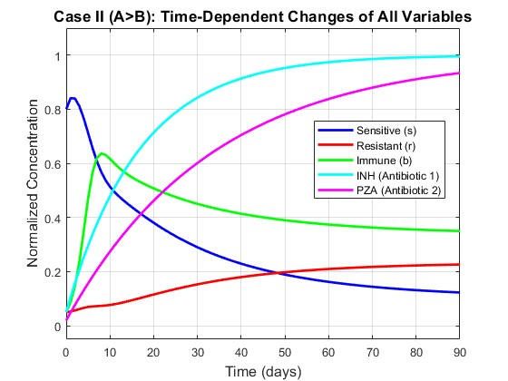
Fig: 2.5 All 5 Variables Over Time (A>B)

Fig: 2.5 — All 5 Variables Over Time shows Unlike Case I, sensitive bacteria do not go to zero — they decline but stabilize at a positive value. Resistant bacteria also persist. Both coexist alongside immune cells at a stable equilibrium, confirming convergence to E₃ as predicted by the model.

The following phase portrait shows the trajectory of sensitive bacteria s against resistant bacteria r over the 90-day period.

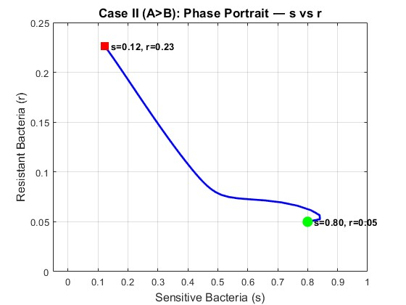
Fig: 2.6 Phase Portrait (s vs r)

Fig: 2.6 — Phase Portrait (s vs r) Shows the trajectory of the system from start (green) to end (red). The path curves toward E₃ where both s and r are positive, visually confirming that neither bacterial strain is eliminated under these conditions.

The following plot shows all three biological populations together to demonstrate coexistence under Case II conditions.

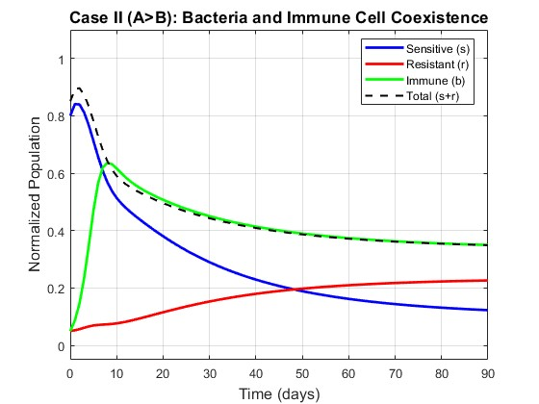
Fig: 2.7 Bacteria and Immune Coexistence

Fig: 2.7 — Bacteria and Immune Coexistence shows All three populations — sensitive, resistant, and immune cells — stabilize at positive values by day 90. The immune system cannot fully clear the infection; instead, a three-way balance is reached. This reflects the biological scenario where antibiotics and immunity together are insufficient to eliminate the bacteria.
Unlike Case I where immune cells converged to the same values resistant bacteria, in Case II immune cells track the total bacterial load s+r which remains higher due to the persistence of sensitive bacteria alongside resistant ones.

Numerical Results — Case II (A > B)
The following table records exact numerical values at 20-day intervals showing convergence toward E3.
Time (days) | Sensitive (s) | Resistant (r) | Total (s+r) | Immune Cells (b) | INH (a1) | PZA (a2)
0 | 0.8000 | 0.0500 | 0.8500 | 0.0500 | 0.0500 | 0.0200
20 | 0.3805 | 0.1155 | 0.4960 | 0.5075 | 0.7139 | 0.4622
40 | 0.2293 | 0.1798 | 0.4091 | 0.4139 | 0.9138 | 0.7048
60 | 0.1622 | 0.2096 | 0.3718 | 0.3740 | 0.9740 | 0.8380
80 | 0.1315 | 0.2228 | 0.3543 | 0.3554 | 0.9922 | 0.9111
100 | 0.1169 | 0.2288 | 0.3457 | 0.3462 | 0.9976 | 0.9512
120 | 0.1095 | 0.2318 | 0.3413 | 0.3416 | 0.9993 | 0.9732
140 | 0.1058 | 0.2333 | 0.3390 | 0.3392 | 0.9998 | 0.9853
160 | 0.1038 | 0.2340 | 0.3378 | 0.3379 | 0.9999 | 0.9919
180 | 0.1027 | 0.2344 | 0.3371 | 0.3372 | 1.0000 | 0.9956
200 | 0.1021 | 0.2347 | 0.3368 | 0.3368 | 1.0000 | 0.9976
220 | 0.1018 | 0.2348 | 0.3366 | 0.3366 | 1.0000 | 0.9987
240 | 0.1016 | 0.2348 | 0.3365 | 0.3365 | 1.0000 | 0.9993
Table: 2.2 Numerical Results — Case II (A > B)
The table records numerical values at 20-day intervals up to day 240. By day 220 the system has effectively converged with changes between consecutive time points less than 0.0002. All three populations s, r and b remain positive throughout — s stabilizes at 0.1016, r at 0.2348, and b at 0.3365 which numerically confirming the theoretical equilibrium E3 = (0.1015, 0.2350, 0.3364, 1, 1) Unlike Case I where sensitive bacteria reached zero, in Case II all populations coexist at positive values as predicted by the A > B threshold condition.
2.4.5 Effect of Immune System Strength
To examine how immune system strength affects the outcome, the immune killing rate η was varied across four values (0.1, 0.3, 0.6, 1.0) while all other parameters were held constant at Case I values.
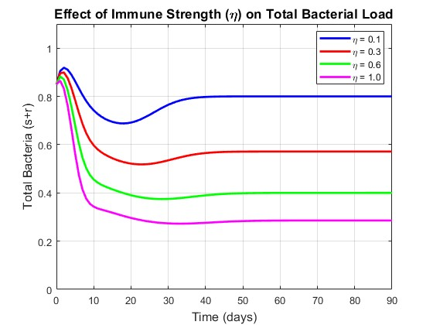
Fig: 2.8 Effect of Immune Strength on Total Bacterial load
The plot shows total bacterial load over 90 days for four values of η (0.1, 0.3, 0.6, 1.0), where η represents the rate at which immune cells kill bacteria.
When η is low (0.1), the immune system is weak and bacterial load remains high throughout the treatment. As η increases, bacteria are cleared faster and settle at a lower equilibrium. At η = 1.0, the bacterial burden is reduced most aggressively. This confirms what the model predicts — a stronger immune response directly lowers the equilibrium bacterial load. In clinical terms, immunocompromised patients (low η) will carry a higher bacterial burden even under the same antibiotic treatment, making recovery harder.

2.4.6 Effect of Fitness Cost
The fitness cost parameter c was varied across four values (0.1, 0.3, 0.5, 0.9) to show its effect on the resistant bacterial population. All other parameters were held at Case I values.
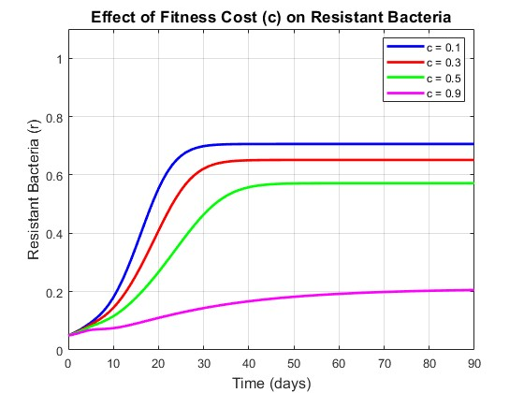
Fig: 2.9 Effect of Fitness Cost in Resistance Bacteria
The plot shows how the resistant bacterial population evolves over 90 days for four values of fitness cost c (0.1, 0.3, 0.5, 0.9), where c directly reduces the growth rate of resistant bacteria as β_R = (1−c) β_S.
When c is small (0.1), resistant bacteria carry almost no fitness penalty and grow rapidly to a high equilibrium level. As c increases, resistant bacteria grow more slowly and stabilize at progressively lower levels. At c = 0.9, the fitness cost is severe and resistant bacteria remain at a very low level throughout. This shows that the biological cost of resistance is a natural limiting factor — the higher the cost, the less dominant resistant strains become. In clinical terms, this suggests that reducing antibiotic pressure can allow high-cost resistant strains to die out naturally over time.

2.4.7 Early Antibiotic Termination
To model the clinical scenario of incomplete treatment, antibiotic supply was set to zero after day 30, day 60, and kept active for the full 90 day course respectively.
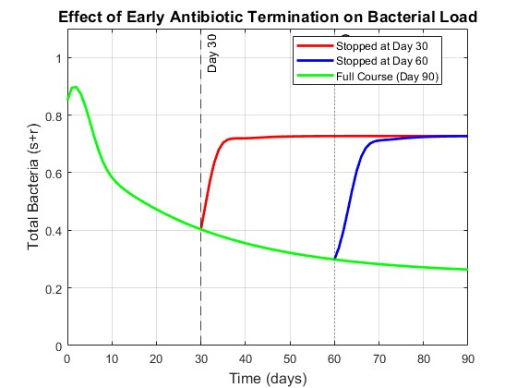
Fig: 2.10 Effect of Antibiotic Termination on Total Bacterial load
The plot compares total bacterial load when antibiotics are stopped at day 30, day 60, or completed for the full 90-day course.
When treatment is stopped at day 30, bacteria rebound sharply after the antibiotics are removed. The immune system alone is insufficient to control the infection and bacterial load climbs back toward high levels. Stopping at day 60 shows a partial rebound — bacteria had been suppressed further before treatment ended, so the rise is slower and settles at a higher level than the full course but lower than the day 30 case. Completing the full 90-day course produces the lowest final bacterial burden, with the system held at the E₂ equilibrium throughout. This result has a direct clinical message — incomplete antibiotic courses not only fail to clear the infection but actively create conditions for bacterial resurgence, and in practice, for resistance amplification.

2.4.8 Single vs Combination Therapy
The following plot shows sensitive bacteria s only, which more clearly demonstrates the difference in clearance speed between the three treatment strategies.
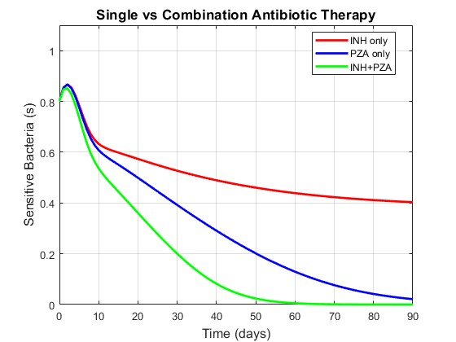
Fig: 2.11 Effect of Single vs Combination Therapy on sensitive bacteria
INH alone fails to eliminate sensitive bacteria by day 90, with s stabilizing at approximately 0.40 — meaning nearly half the sensitive bacterial population survives despite 90 days of treatment. PZA alone eliminates sensitive bacteria by approximately day 85. Combination therapy achieves the fastest clearance, driving sensitive bacteria to zero by approximately day 60 — 25 days faster than PZA alone and far more effective than INH alone. This demonstrates the clear clinical advantage of combination therapy: faster clearance of sensitive bacteria reduces the window during which mutation to resistance can occur, lowering the long-term risk of resistance dominance.

The following plot compares total bacterial load under three treatment strategies using identical initial conditions.
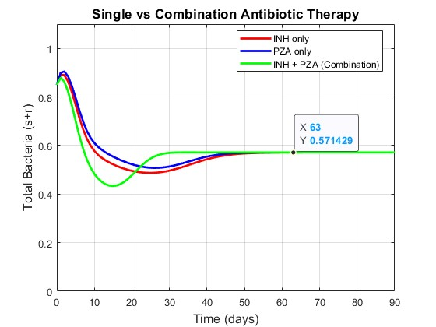
Fig: 2.12 Effect of Single vs Combination Therapy on Total bacteria
The plot compares total bacterial load over 90 days under three treatment strategies: INH alone, PZA alone, and both antibiotics together.
Both single-drug treatments reduce bacterial load but stabilize at a higher equilibrium compared to combination therapy. INH alone performs better than PZA alone due to its stronger killing rate (d1 > d2), but neither single drug suppresses bacteria as effectively as the combination.

